ST PHILOMENA COLLEGE(AUTONOMOUS)
PUTTUR
DEPT OF COMPUTER SCIENCE

SYNOPSIS
TITLE OF THE PROJECT

“AI Crop Disease Detection and Treatment System”
Submitted By:

Shruthy. R.S A.V. Ancilla Mary
(Reg. no: U05PH23C0198) (Reg. no: U05PH23C0201)

Jeevitha
(Reg no: U05PH23C0184)

Submitted On: 10-02-2026

Submitted To:
Internal Guide Head of Department
Dr. Vinayachandra Dr. Vinayachandra
Dept. Computer Science Dept. Computer Science
St.Philomena College (autonomous) Puttur St. Philomena College (autonomous) Puttur

SYNOPSIS

1. TITLE OF THE PROJECT
“AI Crop Disease Detection and Treatment System”

2. INTRODUCTION

2.1 INTRODUCTION

Agriculture is the backbone of India’s economy, and a large percentage of the population depends on farming for their livelihood. One of the major problems faced by farmers is crop diseases, which reduce yield and cause heavy financial losses. Most farmers rely on manual inspection or agricultural experts to identify plant diseases, which is time-consuming, costly, and not always available in rural areas.
With the rapid growth of Artificial Intelligence (AI) and Machine Learning (ML), it has become possible to identify crop diseases automatically using image processing and deep learning techniques. By analyzing images of plant leaves, AI models can detect diseases accurately and provide instant recommendations for treatment.
This project aims to develop an intelligent system that allows farmers to upload crop images and receive disease detection results along with suitable treatment and prevention suggestions. The system also includes an Admin module to manage crop, disease, and treatment information.

2.2 OBJECTIVE

The main objectives of this project are:
- To design an AI-based system to detect crop diseases from leaf images.
- To classify different types of crop diseases using deep learning.
- To provide farmers with treatment and fertilizer recommendations.
- To create a simple and user-friendly web application.
- To help farmers reduce crop loss and improve agricultural productivity.
- To provide an Admin interface to manage disease and treatment data.

3. Project Category and Methodology

3.1 Project Category
- Artificial Intelligence
- Machine Learning

3.2 Methodology
The project follows these steps:
- Collect a dataset of healthy and diseased crop leaf images.
- Preprocess images (resize, normalize, remove noise).
- Train a Convolutional Neural Network (CNN) model to classify diseases.
- Integrate the trained model into a web application.
- The farmer uploads an image, the system predicts the disease and displays treatment and prevention advice.
The project follows the Waterfall Model, where each phase is completed step by step.

4. TOOLS/PLATFORM, HARDWARE AND SOFTWARE REQUIREMENTS

4.1Tools/Platform

Tools Platform
Frontend HTML, CSS, JavaScript
Backend Python, Flask
AI Model TensorFlow, Keras
Database MySQL / SQLite

4.2 Software Requirements (Development)
- Visual Studio Code
- Python
- MySQL
- Web Browser

4.3 Hardware Requirements (Development)
- Windows 7 or above
- 8 GB RAM
- 250 GB Hard Disk
- 2.4 GHz Processor

4.4 Software Requirements (Implementation)
- Web Browser
- Database Server

4.5 Hardware Requirements (Implementation)
- Windows 7 or above
- 8 GB RAM
- 250 GB Hard Disk

5.ANALYSIS

5.1 Module Description

- Farmer Module – Upload crop images and view results.
- Admin Module – Manage disease and treatment data.
- Image Processing Module – Preprocess images.
- AI Disease Detection Module – Predict disease using CNN.
- Recommendation Module – Provide treatment and prevention tips.
- Database Module – Store crop, disease, and treatment data.

5.2 Structure Flow
Farmer → Upload Image → AI Model → Disease Detection → Recommendation → Display Result
Admin → Manage Disease Data → Database

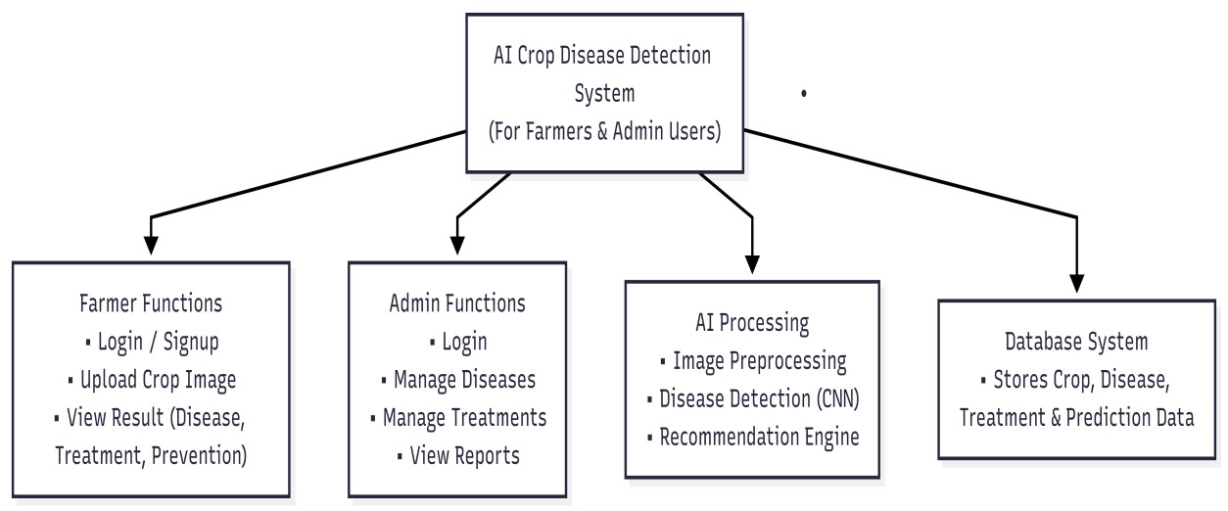
Fig 5.2:Structure flow

5.3 Context Flow Diagram (CFD)
Farmer and Admin interact with the AI Crop Disease Detection System. Farmer uploads images and receives results. Admin manages disease and treatment information.

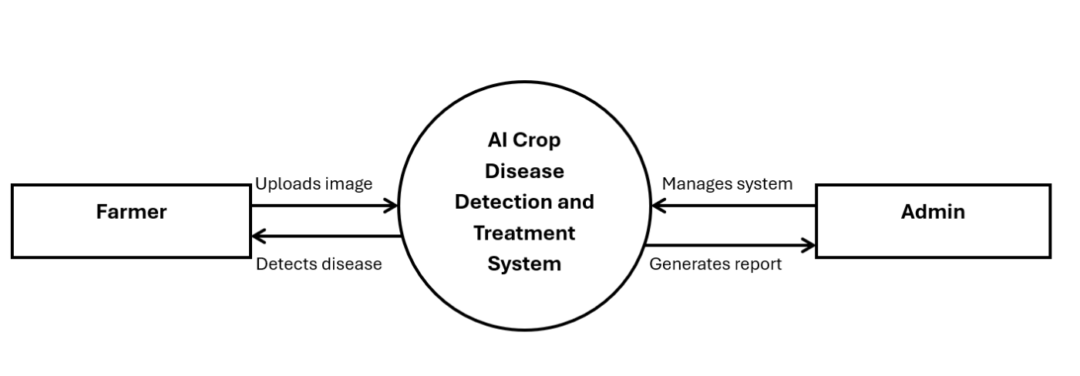

Fig 5.3 Context Flow Diagram

5.4 Data Flow Diagram (DFD Level-1)
Farmer uploads image → Image Processing → AI Model → Disease Database →
Recommendation→ Farmer
Admin updates disease and treatment → Database → System
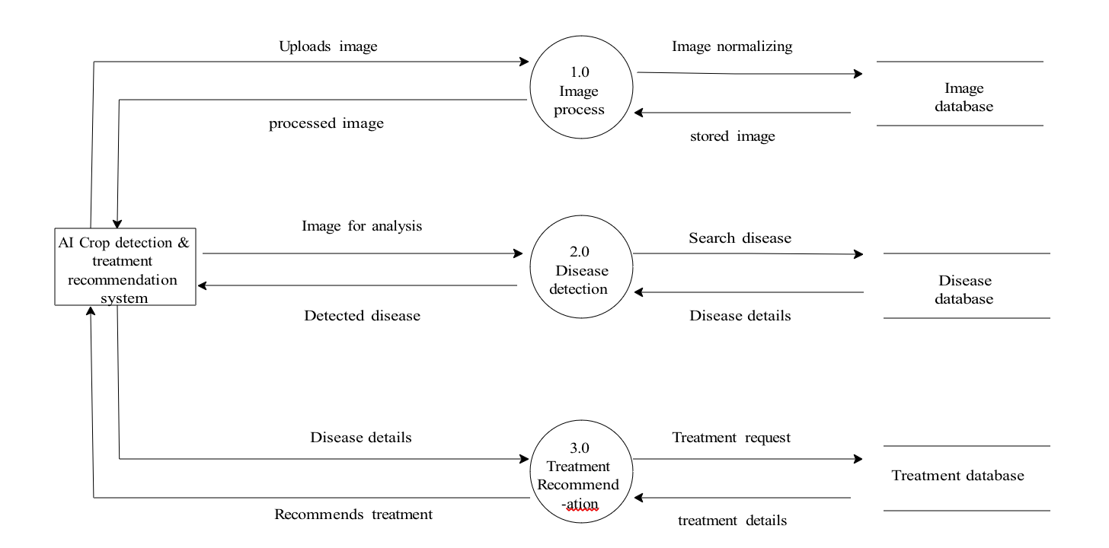 Fig 5.4 DFD level 1

5.5 ER Diagram
Entities:
- Farmer
- Crop
- Disease
- Image
- Treatment
- Prediction

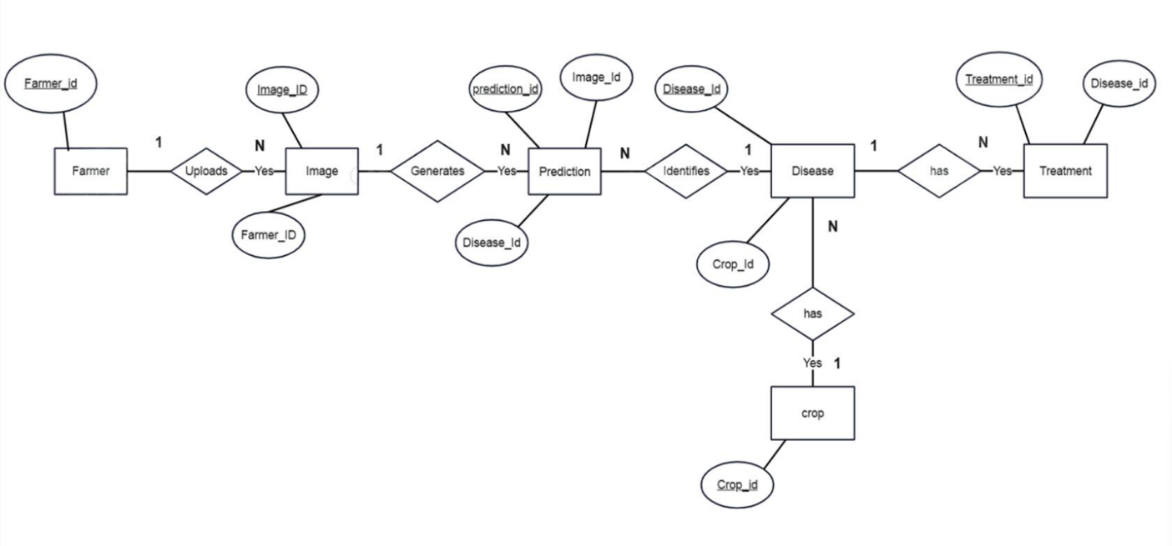

Fig.5.5 ER Diagram

5.6 Database Design
User(Farmer)
User_ID (PK), Name, Email, Password
Image
Image_id,Image_path,Farmer_id
Crop
Crop_ID (PK), Crop_Name
Disease
Disease_ID (PK), Disease_Name, Symptoms, Crop_ID
Treatment
Treatment_ID (PK), Disease_ID, Fertilizer, Pesticide

Prediction
Prediction_ID (PK), Image_ID, Disease_ID, Accuracy

5.7 List of User Screens

Farmer Screens
- Login
- Upload Image
- View Result

Admin Screens
- Login
- Add Disease
- Add Treatment
- View Reports

5.8 Testing
- Unit Testing
- Integration Testing
- System Testing
- User Acceptance Testing

6.Work Plan/TimeLine

Phase | Duration
Requirement Analysis | 1 week
Dataset Collection | 1 week
Model Training | 2 weeks
Application Development | 2 weeks
Testing & Report | 1 week

7. Limitations
- Limited number of crops
- Internet required
- Accuracy depends on image quality

8. Future Scope
- Mobile application
- Support for more crops
- IoT sensor integration
- Multi-language support

9. References
- Maria Diaz (2023). What is Artificial Intelligence. ZDNET
- Mohanty et al. (2016). Plant Disease Detection Using Deep Learning
- Kaggle PlantVillage Dataset

